6) View list of available databases

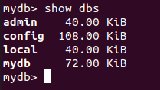

7) Create a new database named cdac and connect to it

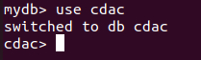

8) View list of collections available in cdac database

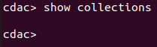

9) Create a new collection by the name of LIBRARY

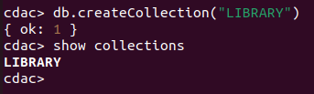

10) Insert the following document in the LIBRARY collection
title : ‘MongoDB programming’, author : ‘Sameer’, likes : 100

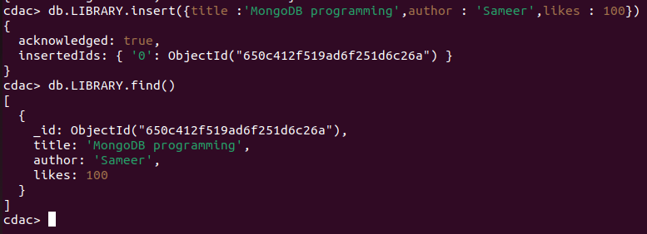

11) View the recently inserted document and note the _id field

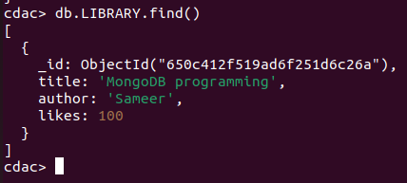

12) Inseet another document in LIBRARY as follows
title : ‘MySQL programming’, authors : [‘Jack’,’Jill’], likes : 200

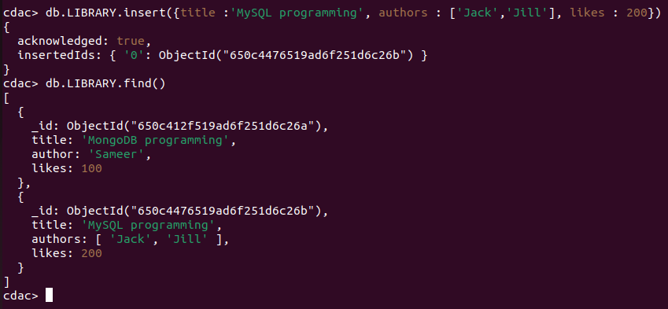

13) View the inserted documents

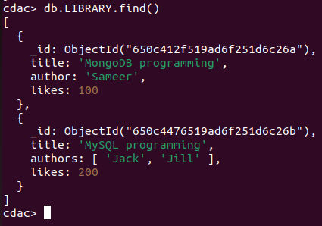

14) View only the first inserted document

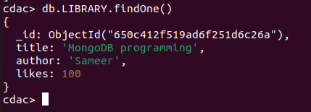

15) View the documents using pretty() method

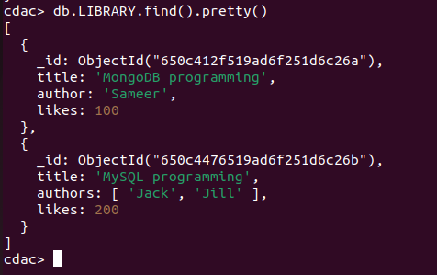

16) Update the document where author name sameer and change it to Sameer Dehadrai
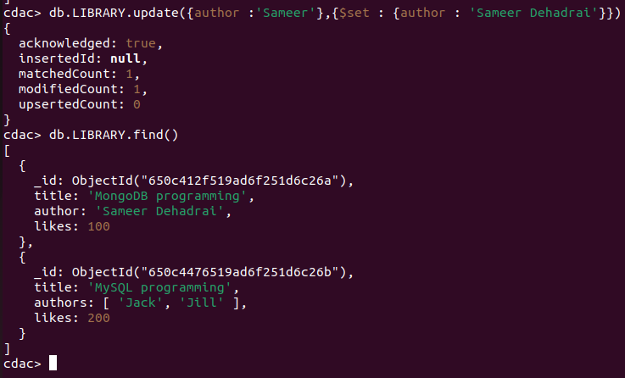

17) Delete all documents that have 100 likes

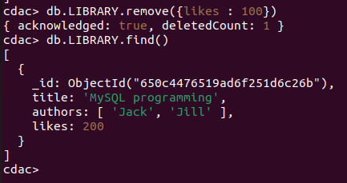

18) Drop the LIBRARY collection

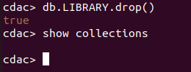

19) Drop the cdac database

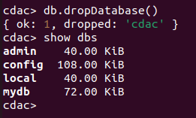

20) Exit from MongoDB



